submission of a fully working code over partially correct but efficient code. Once submitted, you cannot review this problem again. You can
4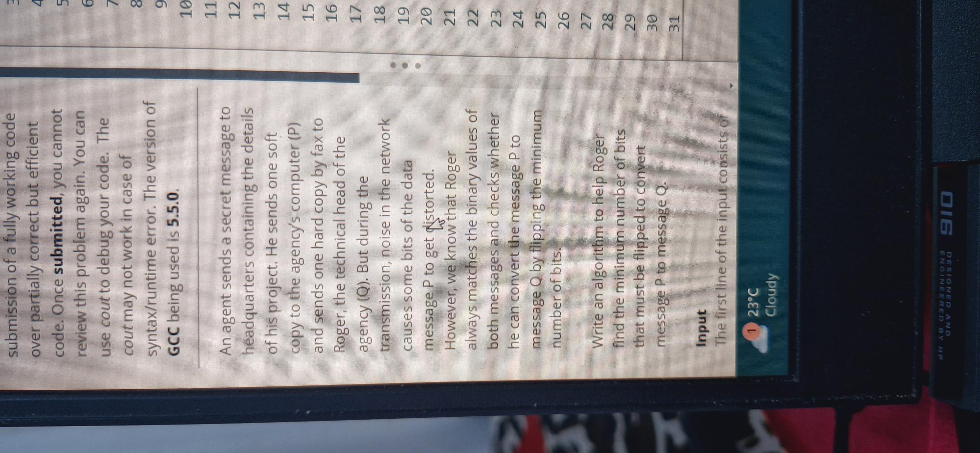
5
6
use cout to debug your code. The cout may not work in case of syntax/runtime error. The version of GCC being used is 5.5.0.
7
8
9
10
11
An agent sends a secret message to headquarters containing the details
12
13
of his project. He sends one soft copy to the agency's computer (P)
14
15
and sends one hard copy by fax to
16
Roger, the technical head of the
17
agency (Q). But during the
transmission, noise in the network
18
causes some bits of the data
19
message P to get distorted.
20
However, we know that Roger
21
always matches the binary values of
22
both messages and checks whether he can convert the message P to message Q by flipping the minimum number of bits.
23
24
25
26
27
Write an algorithm to help Roger
28
find the minimum number of bits that must be flipped to convert message P to message Q.
29
30
31
Input
The first line of the input consists of
23°C Cloudy
910

